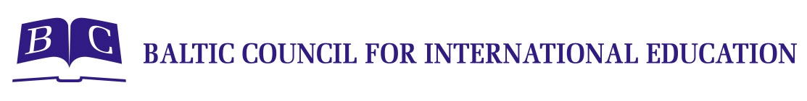
APTIS REGISTRATION FORM 2020
NAME, SURNAME:
Date of Birth:
E-mail Address:
Home Address:
Place of Study or Work:
Date of Payment:
Skill | Price EUR | Tick "✓"  the module you want to do
Core + 1 skill (Reading or Listening) | 48
core + 1 skill (Writing + Speaking) | 60
core + 2 skills  (writing & reading  or writing & listening  or writing & speaking  or reading & listening  or reading & speaking  or listening & speaking) | 70
core + 3 skills  (writing & reading & listening  or writing & reading & speaking  or writing & listening & speaking  or reading & listening & speaking) | 80
core + 4 skills  (writing & reading & listening & speaking) | 100
Preferred exam date:
Please return the form to exams@balticcouncil.org together with your payment slip. | Bank Details:  Account holder: Baltic Council for International Education  Registration No: 40008085919  Account: LV20HABA0551019935194  Bank: SWEDBANK HABA LV 22  Description: Aptis 2020+Name and Surname
Baltic Council for International Education, Ģertrūdes iela 33/35, 3. st., 302. kab., Rīga, LV 1011
T: 00371 67317630 www.balticcouncil.org / exams@balticcouncil.org

